Final Report Template
WeNet Open Call

Please use this template to prepare your final report. It has been organised to ensure that the important aspects of your planned work are clearly measurable with respect to the evaluation criteria.

The structure of this template must be followed when preparing your final report.

The page limit for the final report is 8 pages (Including cover page). Please also respect the limits indicated in each section. The minimum font size allowed is 11 points. The page size is A4, and all margins (top, bottom, left, right) should be at least 20 mm.

The mandatory text style is Arial.

Please delete this page when submitting the report.

Delete the guidance text in blue in each section.

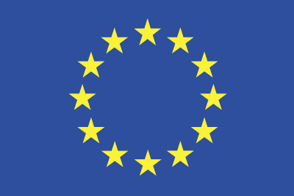
Grant Agreement No.: 823783
Call: H2020-FETPROACT-2018-2020
Topic: H2020-FETPROACT-2018-01
Type of action: RIA

WENET OPEN CALL
Acronym of your project
Full title of your project
Date of submission of the final report

Name of applicant
Institution
Contact email

Overview of the proposal (maximum 1 page)
Indicate by ticking the corresponding box which track you applied for.
Track | Track addressed in the proposal
A)
B)
C)
Table 1 : PROJECT TRACKS

Include a publishable project summary that can be disseminated through the WeNet project website.

Results and achievements (maximum 1 page)
Describe the results achieved by your project. Compare with the expected results as described in your initial application, and explain any deviations.

Project execution (maximum 2 pages)
Describe how the project was executed. Highlight any issues encountered and how it was tackled. Refer to the plan laid out in Sec. 6 of the proposal template, and highlight any deviations.
Use the table below to report on milestones.

Milestone n° | Milestone description | Expected Date (as per proposal) | Actual date
Table 2 : MILESTONES

Ethics and data protection (maximum 2 pages)
Summarise how you adopted an ethical perspective throughout the project's activities.
Describe the methodology that was applied with reference to the data protection. In particular, with reference to tracks A) and B), spell out how the data collected was anonymized in accordance with the GDPR principles and the latest guidelines and best practices.
Remember that you must comply with ethical principles and standards in the scientific and professional responsibilities under the WeNet project. This includes foremost compliance with the WeNet privacy guidelines, especially 6.12 Ethics and Privacy. You are further committed to the ACM Code of Ethics and the EU Draft Ethics Guidelines for Trustworthy AI (if applicable).

Feedback to the WeNet Consortium (minimum 1 page)
Provide feedback on the enablers that were made available by WeNet and that were used throughout your project (WeNet platform, WeNet app, WeNet Research Infrastructure, other).
Highlight what worked well but, more importantly, what could be improved and how.
Tell us how you tackled issues encountered in the usage of WeNet enablers, and on the support you received by the WeNet partners.

